
T K R COLLEGE OF ENGINEERING & TECHNOLOGY
(Autonomous)
B.TECH COMPUTER SCIENCE AND ENGINEERING
OBJECT ORIENTED ANALYSIS AND DESIGN –( B56PC9)
B.Tech VI Sem L/T/P/C
0/0/2/1
COURSE OBJECTIVE:
Write programs for solving real world problems using java language.
COURSE OUTCOMES:
After learning the contents of this course, the student must be able to
- Write programs for solving real world problems using java collection frame work L3
- Write programs using abstract classes.L3
- Design and develop programs using objects and inheritance in Java language.L5
- Write multithreaded programs.L3
List of programs:
Consider the following three case studies:
Online course reservation system, E-ticketing, Library Management System
Week 1
Familiarization with Rational Rose or Umbrello For each case study develops a problem statement.
Week 2, 3 & 4:
For each case study:
1) Identify and analyze events
2) Identify Use cases
3) Develop event table
4) Identify & analyze domain classes
5) Represent use cases and a domain class diagram using Rational Rose
6) Develop CRUD matrix to represent relationships between use cases and problem domain
Classes
Week 5 & 6:
For each case study:
1) Develop Use case diagrams
2) Develop elaborate Use case descriptions & scenarios
3) Develop prototypes (without functionality)
4) Develop system sequence diagrams
Week 7, 8, 9 & 10:
For each case study:
1) Develop high-level sequence diagrams for each use case
2) Identify MVC classes / objects for each use case
3) Develop Detailed Sequence Diagrams / Communication diagrams for each use case showing
Interactions among all the three-layer objects
4) Develop detailed design class model (use GRASP patterns for responsibility assignment)
5) Develop three-layer package diagrams for each case study
Week 11 & 12:
For each case study:
1) Develop Use case Packages
2) Develop component diagrams
3) Identify relationships between use cases and represent them
4) Refine domain class model by showing all the associations among classes

Week 13 onwards:
For each case study:
1) Develop sample diagrams for other UML diagrams – state chart diagrams, activity diagrams
and deployment diagrams.

WEEK-1
1. Familiarization with Rational Rose or Umbrello For each case study develops a problem statement.

Umbrello UML Modeler app and code generator

Umbrello is a free and open source Unified Modeling Language modeler and code generator application for Linux, MacOS, and Windows. With UML you can create diagrams of software and other systems in a standard format to document or design the structure of your programs. It is released under the GNU General Public License v2.0 or later and a kde project. Supports XMI formats and use case, class, sequence, communication, state, activity, component, implementation, and entity relationship diagrams.

Install Umbrella on Ubuntu Linux
Umbrella is available as an out-of-the-box package for Ubuntu Linux. You can install it through the terminal app. Open the terminal app with ctrl+alt+t keys and run below umbrello instant install command.
sudo snap install umbrello
After installation, you can open it through the application menu or by using the following command in terminal.
umbrello
If you don't need it, uninstall it using the following command.

sudo snap remove umbrello

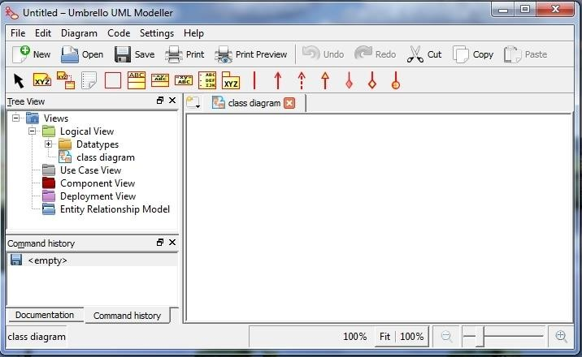

How to Install Umbrello (UML Modeler) On Windows 7

Introduction
Umbrello (UML Modeler):
Umbrello UML Modeler is a free software UML diagram tool available natively for Unix- like platforms, as well as Microsoft Windows (as part of KDE-Windows). It is part of the KDE SC 4 but works well with other desktops and programming environments. Umbrello is a pretty simple UML editor though it does support a range of different views and diagrams. It makes it as easy as possible to draw a simple diagram, then lets you alter and add to it as your design is refined. Everything seems to work fine under Linux with the exception of exporting to an image.

KDE For Windows
KDE for Windows is an ongoing project to port the KDE applications to MS Windows. Currently supported versions of Windows are XP, Vista and 7

Requirement:

- KDE For Windows
  - Download : http://windows.kde.org/
- Umbrello
  - Download and installation with KDE For Windows

Installing KDE for Windows and Umbrello

- Double click KDE installer (*.exe file, example : kdewin-installer-gui-latest.exe), You will see a window that looks like this

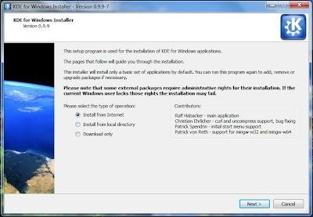

- Choose “Install from Internet” for type operation, and then click the “Next >” button at the bottom of the screen.
- On the window “Installation Directory”, click the “Browse …” button to change default directory, and then click the “Next >” button.
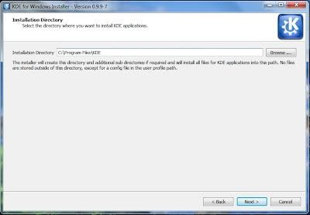
- On the window “Install Mode” :
  - Click the radio button “End User” on dialog Install Mode,
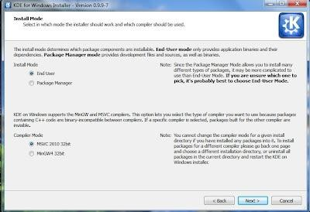
  - Click the radio button “MSVC 2010 32bit” on dialog Compiler Mode, and then click the “Next >” button.

- On the window “Local Storage Setting”, click the “Browse …” button to change default directory, and then click the “Next >” button.

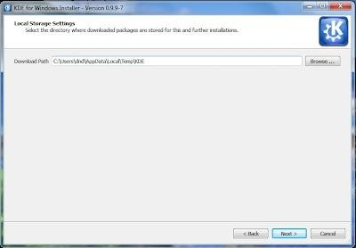

- On the window “Internet Setting”, click the radio button “I have a direct connection to the internet”, and then click the “Next >” button.

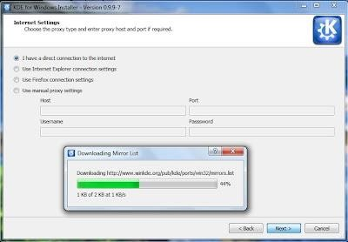
- In the window “Download Server Setting”, Choose “Central Europe, Germany (http://www.winkde.org)” to install the application,and then click the “Next” button.
- The next step wait for download Release.

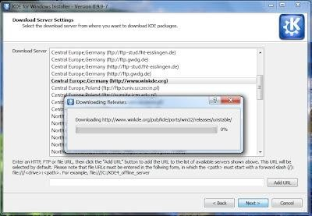
- The next step, On the window “Release Selection”, choose Stable Release for Available Release, an then click the “Next >” button.

- The next step waits for download Package List.
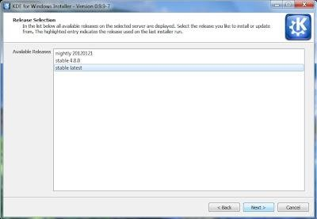
- In the window “Package Selection”, choose “Umbrello” to install the application, and then click the “Next >” button.

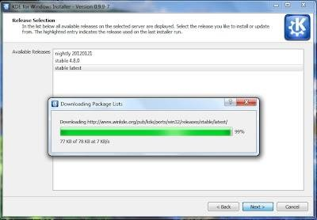

- The next step, you will get a confirmation on the package will be downloaded, click the “Next >” button to download and install packages.
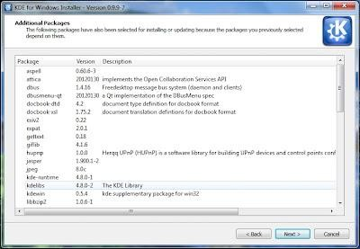
- The next step waits for download Packages and the finished installation.

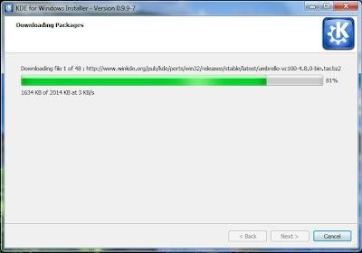

- To complete the installation process clicks the “Finish” button. You should see a window that looks like this :
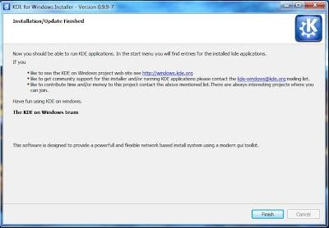

Running Umbrello (UML Modeler)

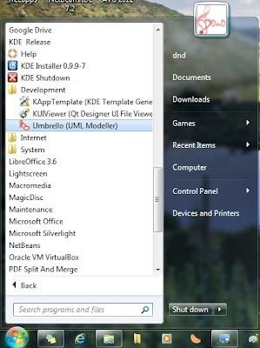
- To open Umbrello, Go to Start Menu à All Programs à KDE Release a Development à Umbrello (UML Modeler).

- You will see a window that looks like this :

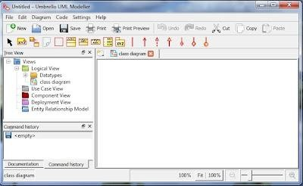

CASE STUDY: ONLINE COURSE RESERVATION
Week 2, 3 & 4:
For each case study:
1) Identify and analyze events
2) Identify Use cases
3) Develop event table
4) Identify & analyze domain classes
5) Represent use cases and a domain class diagram using Rational Rose
6) Develop CRUD matrix to represent relationships between use cases and problem domain
Classes
Week 5 & 6:
For each case study:
1) Develop Use case diagrams
2) Develop elaborate Use case descriptions & scenarios
3) Develop prototypes (without functionality)
4) Develop system sequence diagrams
Week 7, 8, 9 & 10:
For each case study:
1) Develop high-level sequence diagrams for each use case
2) Identify MVC classes / objects for each use case
3) Develop Detailed Sequence Diagrams / Communication diagrams for each use case showing
Interactions among all the three-layer objects
4) Develop detailed design class model (use GRASP patterns for responsibility assignment)
5) Develop three-layer package diagrams for each case study

Week 11 & 12:
For each case study:
1) Develop Use case Packages
2) Develop component diagrams
3) Identify relationships between use cases and represent them
4) Refine domain class model by showing all the associations among classes
Week 13 onwards:
For each case study:
1) Develop sample diagrams for other UML diagrams – state chart diagrams, activity diagrams
and deployment diagrams.
Problem statements of Online course reservation system
AIM:
To create a system through which students can register to the courses desired by them.
PROBLEM STATEMENT:
- The system is built to be used by students and managed by an administrator.
- The student and employee have to login to the system before any processing can be done.
- The student can see the courses available to him/her and register to the course he/she wants.
- The administrator can maintain the course details and view all the students who have registered to any course.

Week 2, 3&4
Case Study 1: Online course reservation system
- Identify the users and Analyze Events
- Identify Use cases
- Develop event table
- Identify & analyze domain classes
- Represent Use cases & Domain class diagram using Umbrello
- Develop CRUD matrix to represent relationships between use cases and problem domain classes.
a) Identify and Analyze Events
USERS | EVENTS
Registrar/Admin | 1. Refers to the super user with the privilege to manage the entire system.  2. He has the certain privileges to add the course status and to approve the issue of course.  3. He may contain a group of persons under him to verify the documents and give suggestion whether or not to approve the dispatch of course.
Applicant | 1. One who wishes to register the Course  2. Submit the information to the database.
OCRS | Secure Reservation of information by the Students.  • SMS and Mail updates to the students by the Registrar  • Registrar can generate reports from the information and is the only authorized personnel to add the eligible application information to the database.

b) Identify Use cases
- A use case diagram shows a set of use cases and actors (a special kind of class) and their relationships. Use case diagrams address the static use case view of a system.
- These diagrams are especially important in organizing and modeling the behaviors of a system.
The following are the use cases:
1. Login
2. View course details
3. Reserve for course
4. Pay fee
5. Check status

ACTORS INVOLVED:
1. Student
2. Registrar
c) Develop event table
 |  | Login | View course details | Reserve for course | Storing details in database | Pay fee | Check status
User enters username and password |  | *
Checks whether the username and password entered is valid or not |  | *
Checks whether user is student or registrar |  | *
Students can search all the details available and choose the best course they want |  | * | *
Students can view the course duration, faculty and department of the course he may choose |  | * | *
Registering for the course |  |  |  | +
Upon successful registration have to pay storing the student details in database |  | * | * | * |  | +
after registration to course student may see the details of current course and pay the fees |  | * |  | + |  | *
The student tries to check the status in which category they applied. The system displays the status information to the student. |  | * | * |  |  |  | *
* Event can occur zero to many times
+ Event can occur zero to one time
d) Identify & analyze domain classes
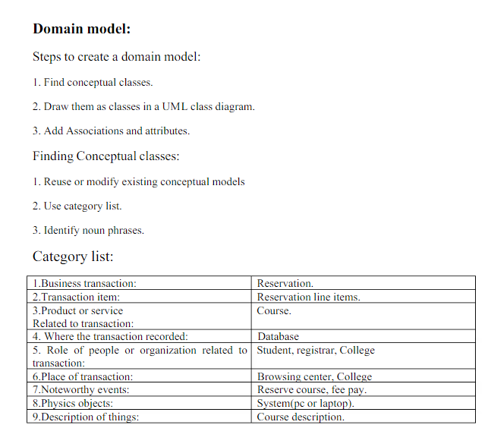

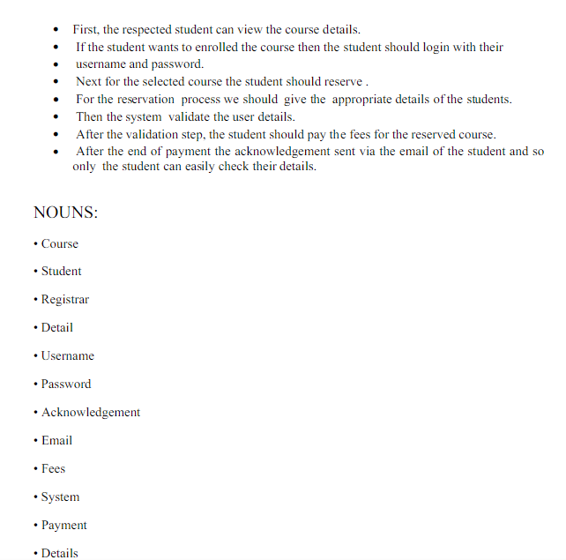

Domain Model:
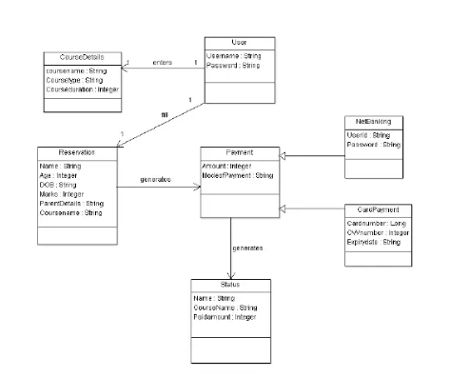
e) Represent Use cases & Domain class diagram using Umbrello
Student
They are the person who desires to obtain the course and submit the information to the database.
Registrar
He has the certain privileges to add the course status and to approve the issue of course. He may contain a group of persons under him to verify the documents and give suggestion whether or not to approve the dispatch of course.

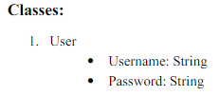
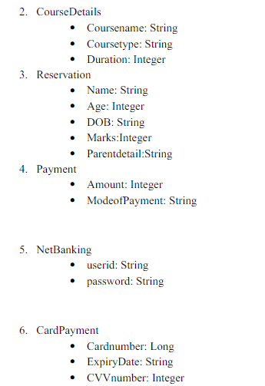
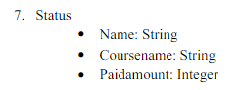

CLASS DIAGRAM

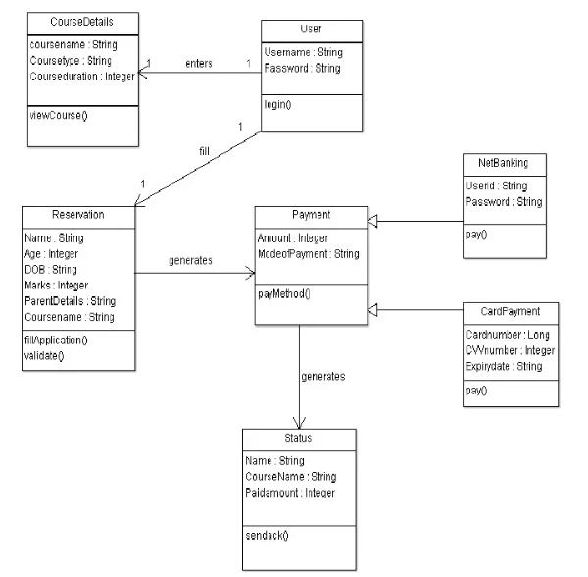

f) Develop CRUD matrix to represent relationships between use cases and problem domain classes

CRUD technique – an acronym for Create, Read/Report, Update, and Delete; a technique to
validate or refine use cases
- The CRUD Matrix is an excellent technique to identify the Tables in a Database which are used in any User interaction with a Web Site.
- CRUD means ‘Create, Read, Update or Delete’, and the CRUDD Matrix identifies the Tables involved in any CRUD operation.
- It is very valuable to combine a CRUD Matrix with the analysis of possible User Scenarios for the Web Site
- The analysis helps to identify any Tables which are not used, and any Tables which are used heavily, and may therefore be a performance bottleneck.

Use case/Class | Student | Course | College
Login/Register | C
View Course Details | R | C
Reserve for Course | R | U | U
Pay fee | U | R | R
Check Status | R | R | R

Week-5 & 6
a) Develop Use Case diagrams
b) Develop elaborate Use case descriptions & scenarios
c) Develop Prototypes
d) Develop system sequence diagrams.

a) Use case Diagram
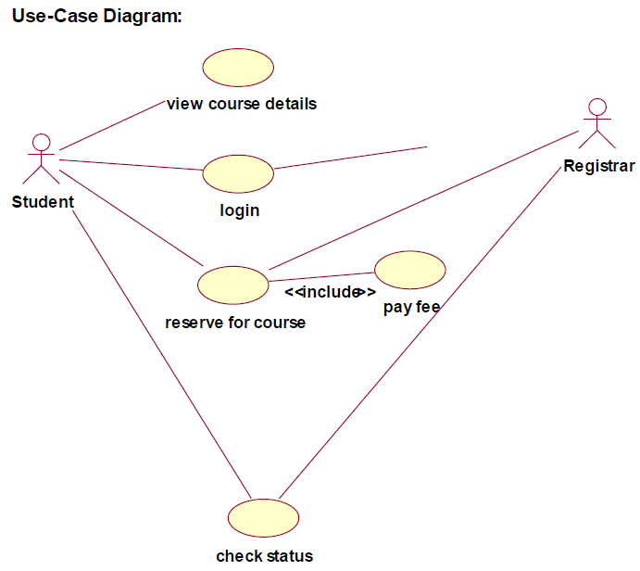
b) Elaborated use-cases descriptions
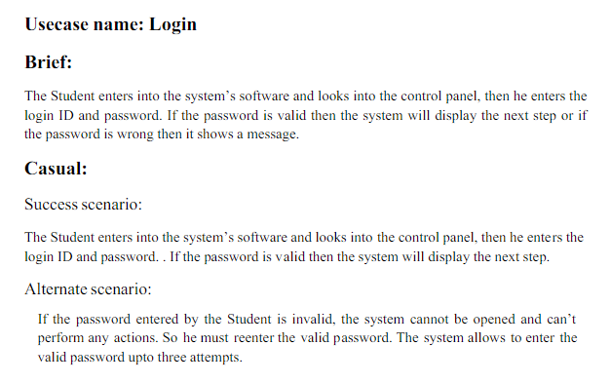
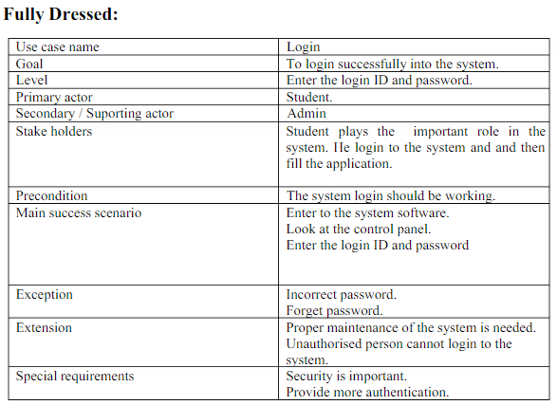
USECASE NAME: View course details

- In this, a student can search all the courses available to him and
choose the best course he wants.
- The student can view the course duration, faculty and department of the courses he may
choose.
USECASE Name: Reserve for course
- When a student has successfully chosen a course, he can register to that course.
- Upon registration, the student’s details are stored in the database.

USECASE NAME: Pay fee
- After registration to any course, the student may see the details of his current course. He may wish to know details about fees and other information.

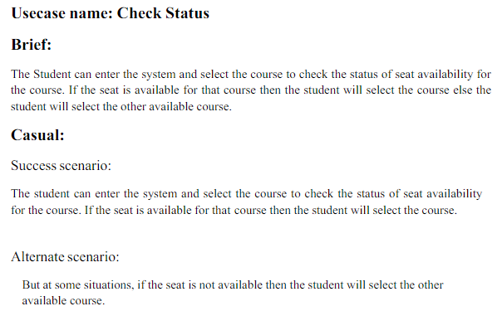
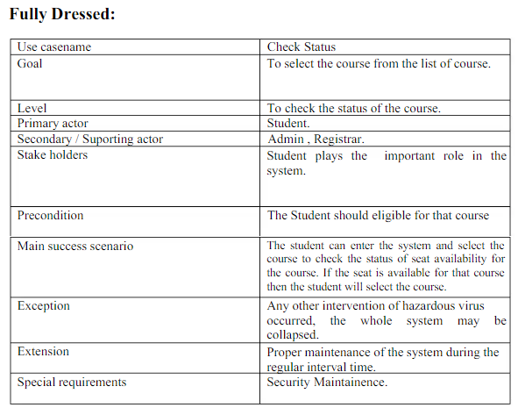

Elaborated Use Case Diagram
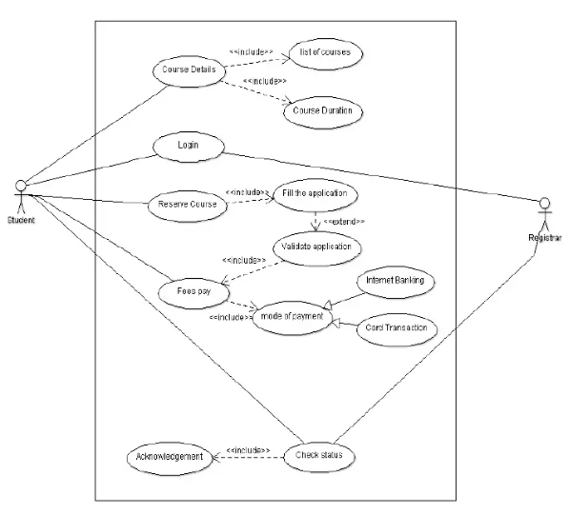
c) Develop prototypes

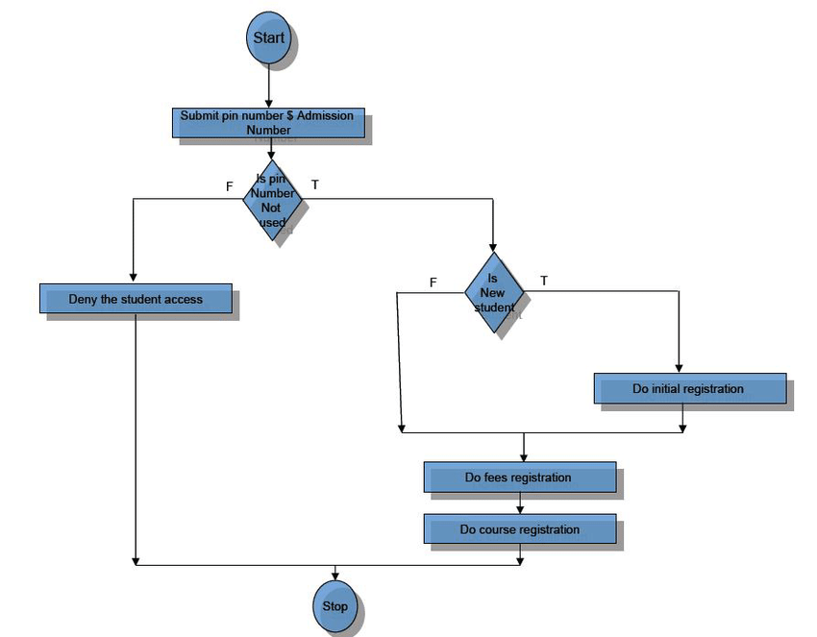

d) Develop system sequence diagrams.
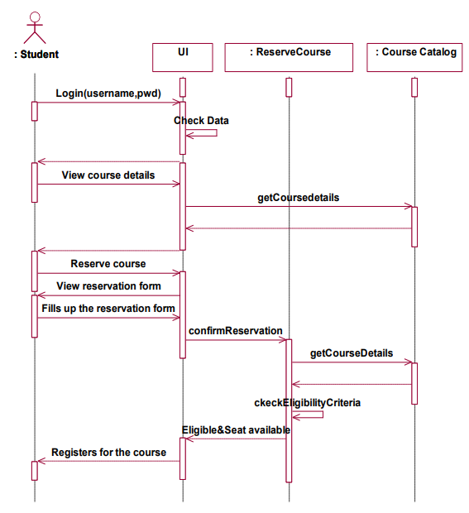

Week 7, 8, 9 & 10:
For each case study:
- Develop high-level sequence diagrams for each use case
- Identify MVC classes / objects for each use case
- Develop Detailed Sequence Diagrams / Communication diagrams for each use case showing interactions among all the three-layer objects
- Develop detailed design class model (use GRASP patterns for responsibility assignment)
- Develop three-layer package diagrams for each case study

1. High-level sequence diagram for Online Course reservation system
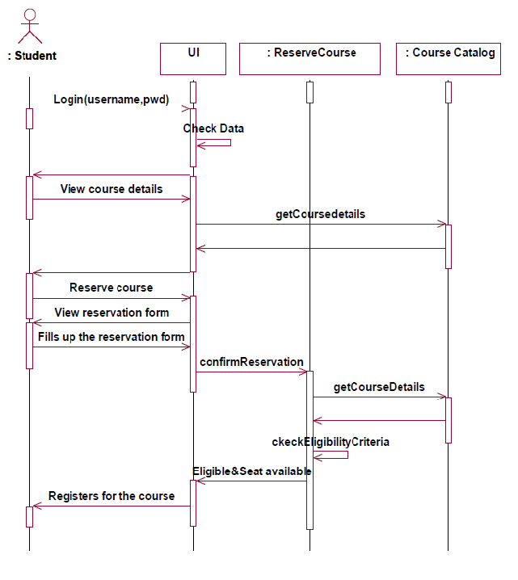

2. Identify MVC classes / objects for each use case
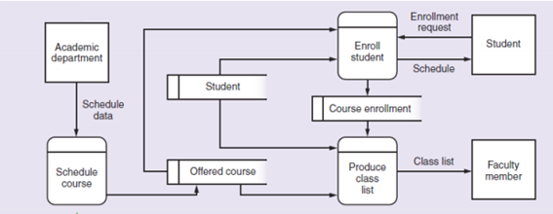
3. Detailed Sequence Diagrams / Communication diagrams
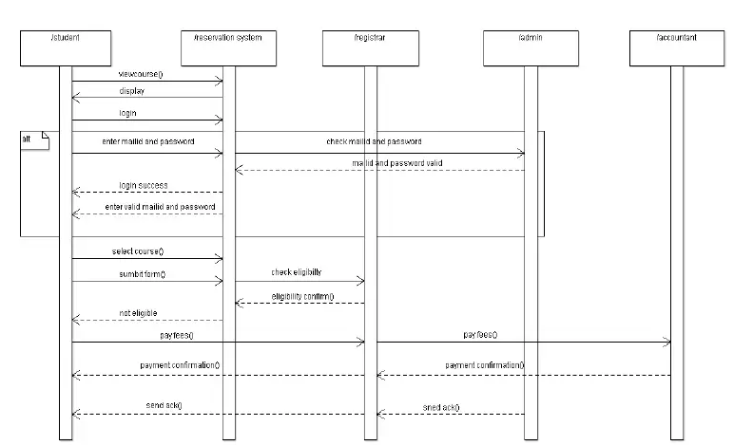
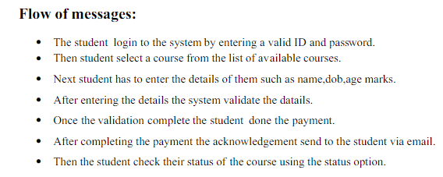
4. Develop detailed design class model
CLASS DIAGRAM:
The class diagram is a graphical representation of all the classes used in the system and their operations, attributes and relationships.
The course registration system makes use of the following classes:
1. Student
2. Course Catalog
3. Reserve Course
1) STUDENT:
- It consists of the details of all the students present in the database.
- The attributes present in this class are student id, student name, student qualification, student address1, student address2, student address3, student mobile no, student emailed,, student dob, student gender.
- The object of this class is created as soon as the student registers to a course.
- The operations available to this class are add details (), modify details (), del details (), reserve course ().
2) COURSE CATALOG:
- The course catalog class consist of course id, course name, course duration course fee, course eligibility, total no of seat, course avail seat.
- The operations are add course(), update course(), del course().

3) RESERVE COURSE:
- The reserve catalog class consists of student id, course id, date, amt paid, reg id, DD no.
- The operation are get course details(), check eligibility(), confirm registration().
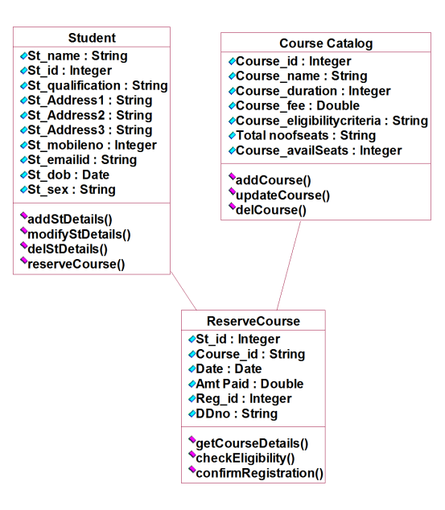
Fig: detailed design class model
Week 11 & 12:
For each case study:
- Develop Use case Packages
- Develop component diagrams
- Identify relationships between use cases and represent them
- Refine domain class model by showing all the associations among classes

COMPONENT DIAGRAM:
Component diagrams are used to visualize the organization and relationships among components in a system.
Week13onwards: For each case study:
- Develop sample diagrams for other UML diagrams – state chart diagrams, activity diagrams and deployment diagrams.

STATE CHART DIAGRAM:
Every object undergoes through some state and on receiving some event the state gets
Changed. This transition of the state can be represented by the state transition diagram
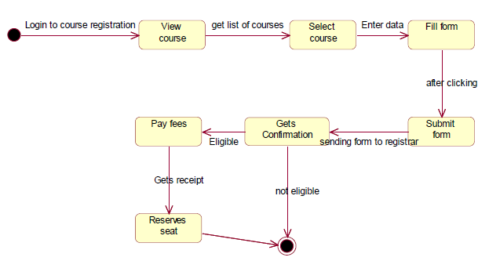
Activity Diagram:

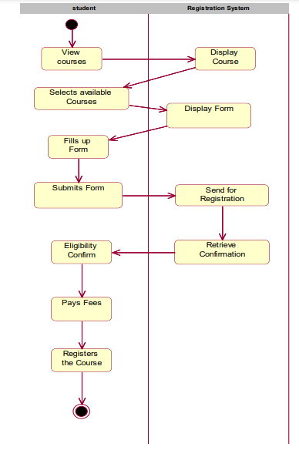
Detailed Activity Diagram
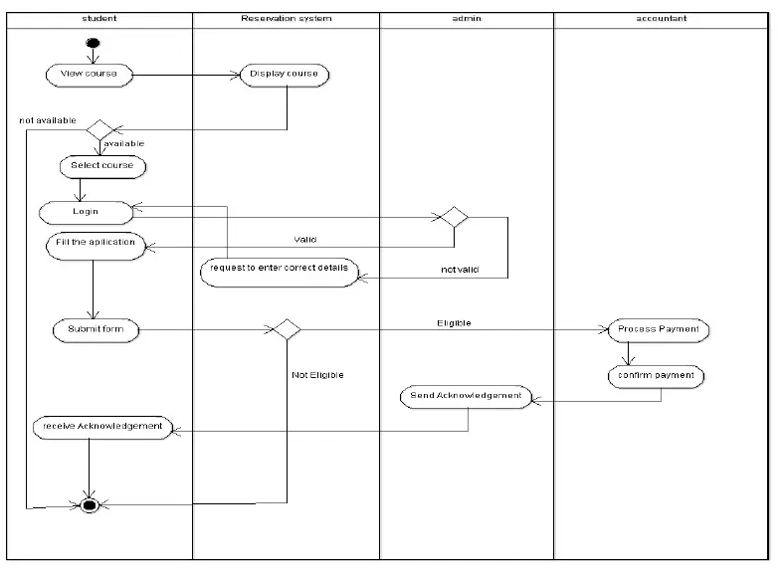
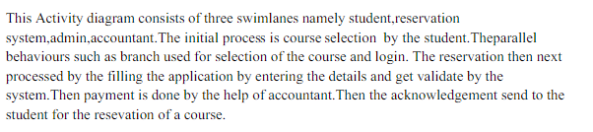

DEPLOYMENT DIAGRAM

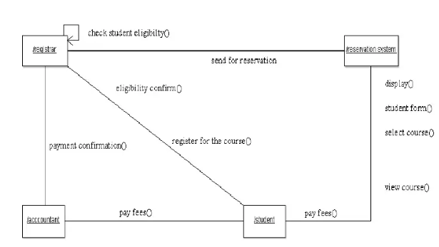
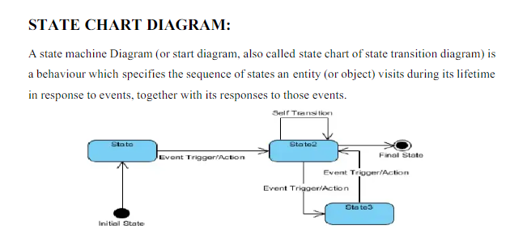
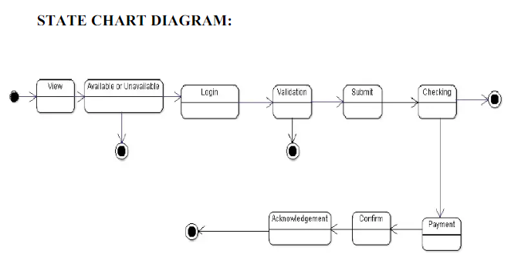

CASE STUDY: LIBRARY MANAGEMENT SYSTEM
Week 2, 3 & 4:
For each case study:
1) Identify and analyze events
2) Identify Use cases
3) Develop event table
4) Identify & analyze domain classes
5) Represent use cases and a domain class diagram using Rational Rose
6) Develop CRUD matrix to represent relationships between use cases and problem domain
Classes
Week 5 & 6:
For each case study:
1) Develop Use case diagrams
2) Develop elaborate Use case descriptions & scenarios
3) Develop prototypes (without functionality)
4) Develop system sequence diagrams
Week 7, 8, 9 & 10:
For each case study:
1) Develop high-level sequence diagrams for each use case
2) Identify MVC classes / objects for each use case
3) Develop Detailed Sequence Diagrams / Communication diagrams for each use case showing
Interactions among all the three-layer objects
4) Develop detailed design class model (use GRASP patterns for responsibility assignment)
5) Develop three-layer package diagrams for each case study

Week 11 & 12:
For each case study:
1) Develop Use case Packages
2) Develop component diagrams
3) Identify relationships between use cases and represent them
4) Refine domain class model by showing all the associations among classes
Week 13 onwards:
For each case study:
1) Develop sample diagrams for other UML diagrams – state chart diagrams, activity diagrams
and deployment diagrams.
Problem statements of Library Management System
The library system is a web-based application which is designed for automating a library
It allows the librarian to maintain the information about
Books
Magazines
CDs
Its users
Furthermore, it should provide the following facilities to its users
Search for items
Browse
Checkout items
Return items
Make reservation
Remove reservation, etc.
For borrowing the item from the library, any user must get registered in the system initially
- The users can search for any item in the library by using the 'search option'
- If the user finds the item he/she is searching for in the library, he/she can checkout the item from the library
- If the study material is not available in the library at the moment, the user can make reservation for that item
- The moment the item is available, the user who first reserved for that item is notified first
- If the user checks out the item from the library, the reservation gets cancelled automatically.
- The reservation can also be cancelled through an explicit cancellation procedure
The librarian is an employee of the library who interacts with the borrowers whose work is supported by the system
The system allows the librarian to perform the following functions with a lot of ease
- Create
- Update
- Delete information about titles
- Borrowers
- Items and reservations in the system
Week 2, 3&4
Case Study 1: Library Management System
- Identify the users and Analyze Events
- Identify Use cases
- Develop event table
- Identify & analyze domain classes
- Represent Use cases & Domain class diagram using Umbrello
- Develop CRUD matrix to represent relationships between use cases and problem domain classes.
a) Identify and Analyze Events
USERS | EVENTS
New user register | 1.To sign up a new user to this system
Student Login | 1.So as to confirm that only an authenticated user is using the project
Search book | The user can search book based on book id, book name, or by author name.
Issue Book | To help the user get the required books issued.
Return Book | To return the book before the last date without fine, or after the specified time duration with a late fine.
Admin | It is to be operated by the admin with a unique id and password. The admin is the person who decides authentication and authorization for all the different users of the application.
Librarian | Includes all the library staff who are required to enter the records in the system and keep an eye on the various activities like the issue of the book, the return of the book, non-availability of books, etc.
b) Identify Use cases
Actor vs Usecase:
Librarian
- Issue a book
- Update and maintain records
- Request the vendor for a book
- Track complaints

User
- Register
- Login
- Search a book
- Request for issue
- View history
- Request to the Librarian
- Unregister

Books Database
- Update records
- Show books status
Vendors
- Provide books to the library
Payment acknowledgement

c) Develop event table
 |  |  | New users  Registers | Student login | Search for books | Issue books | Return book | Admin | Librarian
To sign up a new user to this system |  |  | *
So as to confirm that only an authenticated user is using the project |  |  | + | + | * | *,+ | *,+ |  | *
The user can search book based on book id | book name |  |  | + | * | * | * |  | *
To help the user get the required books issued. |  |  |  | * | * |  | * | + | *
To return the book before the last date without fine, or after the specified time duration with a late fine. |  |  |  | + |  | + | + | * | *
It is to be operated by the admin with a unique id and password. The admin is the person who decides authentication and authorization for all the different users of the application. |  |  | + | + | + | * | * | + | +
Includes all the library staff who are required to enter the records in the system and keep an eye on the various activities like the issue of the book, the return of the book, non-availability of books, etc. |  |  | * | * | * | * | * | + | +
* Event can occur zero to many times
+ Event can occur zero to one time
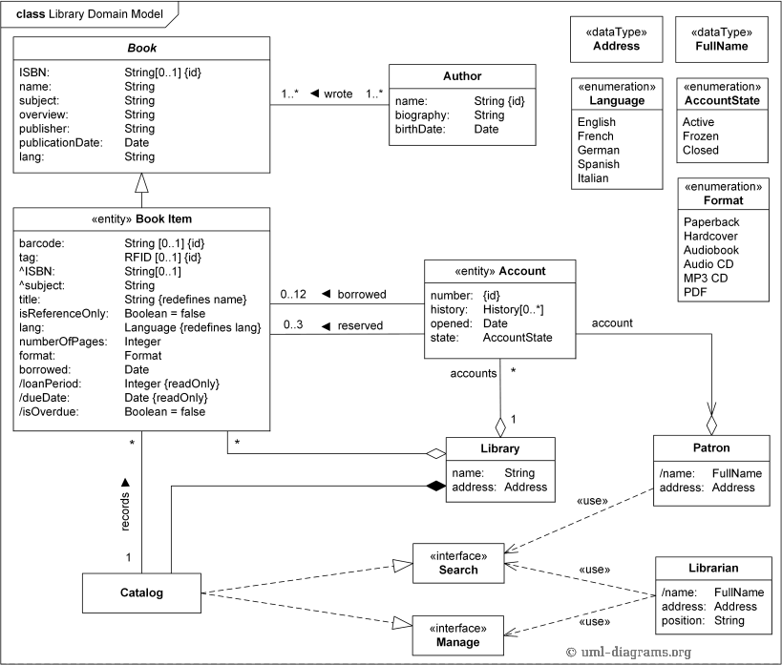
d) Identify & analyze domain classes

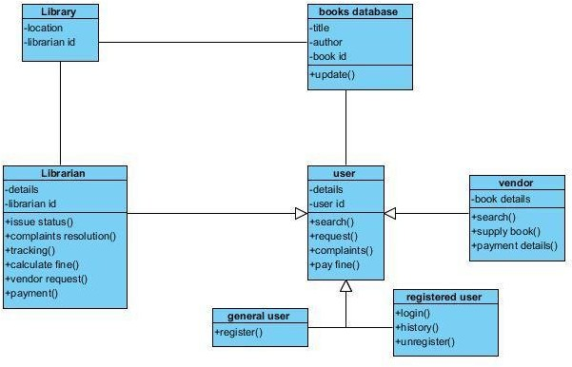
Domain Model:

e) Represent Use cases & Domain class diagram using Umbrello
- Class Diagram
Classes identified:
Library
Librarian Books Database
User vendor

Use-case Diagram

Actors vs Use Cases: Librarian
- Issue a book
- Update and maintain records
- Request the vendor for a book
- Track complaints

User
- Register
- Login
- Search a book
- Request for isse
- View history
- Request to the Librarian
- Unregister

Books Database
- Update records
- Show books status
Vendors
- Provide books to the library
- Payment acknowledgement
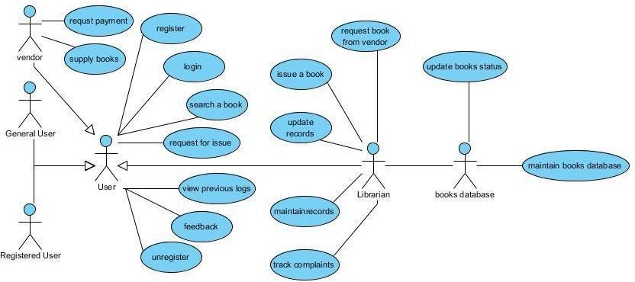

f) Develop CRUD matrix to represent relationships between use cases and problem domain classes
CRUD technique – an acronym for Create, Read/Report, Update, and Delete; a technique to
validate or refine use cases
- The CRUD Matrix is an excellent technique to identify the Tables in a Database which are used in any User interaction with a Web Site.
- CRUD means ‘Create, Read, Update or Delete’, and the CRUDD Matrix identifies the Tables involved in any CRUD operation.
- It is very valuable to combine a CRUD Matrix with the analysis of possible User Scenarios for the Web Site
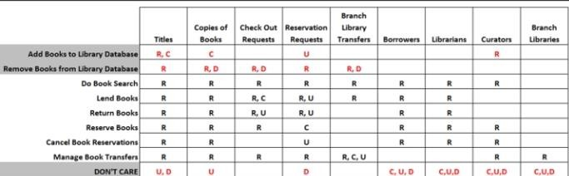
- The analysis helps to identify any Tables which are not used, and any Tables which are used heavily, and may therefore be a performance bottleneck

Week-5 & 6
a) Develop Use Case diagrams
b) Develop elaborate Use case descriptions & scenarios
c) Develop Prototypes
d) Develop system sequence diagrams.
a) Use case Diagram
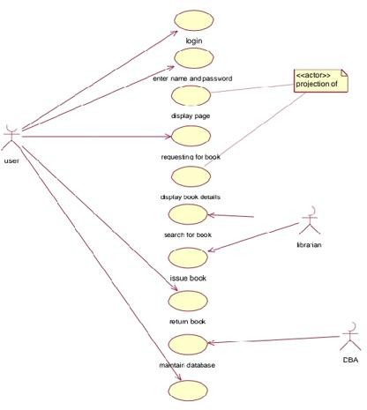
b) Elaborated use-cases descriptions
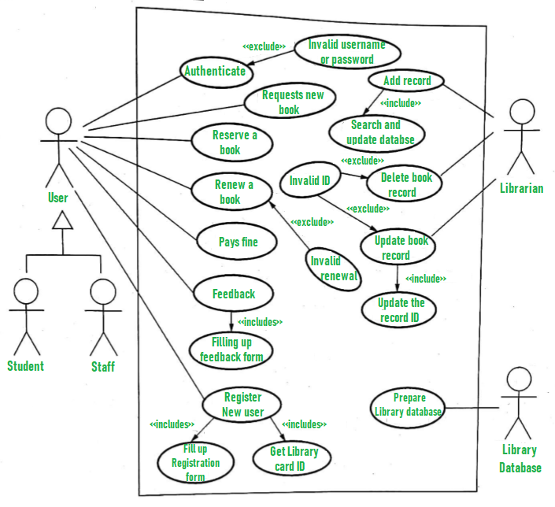
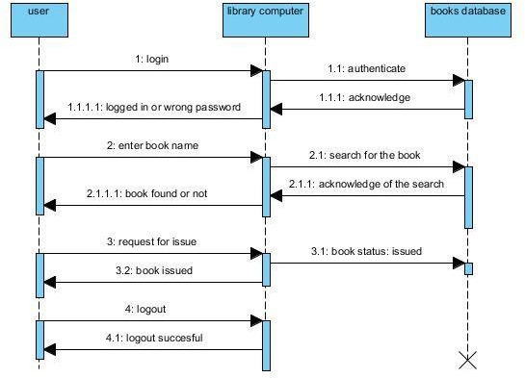
c) Develop system sequence diagrams
Week 7, 8, 9 & 10:
For each case study:
- Develop high-level sequence diagrams for each use case
- Identify MVC classes / objects for each use case
- Develop Detailed Sequence Diagrams / Communication diagrams for each use case showing interactions among all the three-layer objects
- Develop detailed design class model (use GRASP patterns for responsibility assignment)
- Develop three-layer package diagrams for each case study
1. High-level sequence diagram for library management system:
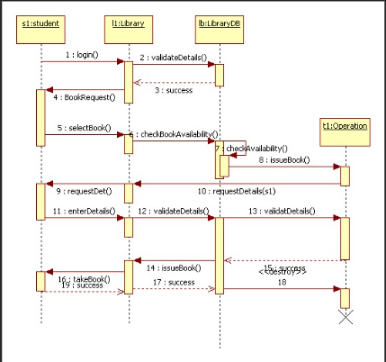
3. Detailed Sequence Diagrams / Communication diagrams
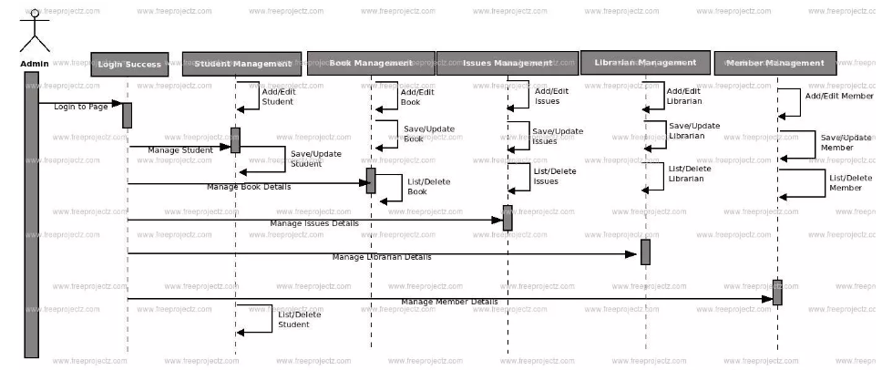

4. Develop detailed design class model
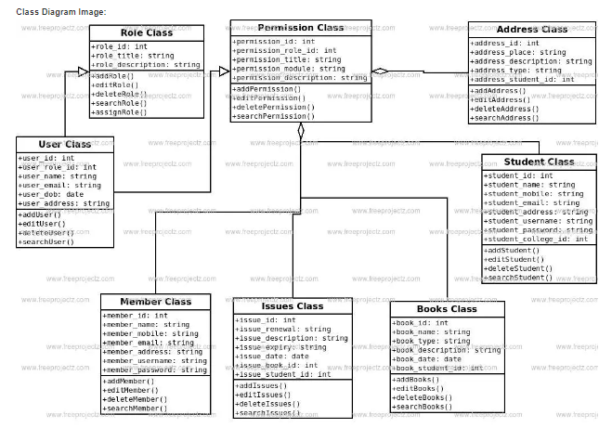
Week 11 & 12:
For each case study:
- Develop Use case Packages
- Develop component diagrams
- Identify relationships between use cases and represent them
- Refine domain class model by showing all the associations among classes

COMPONENT DIAGRAM:
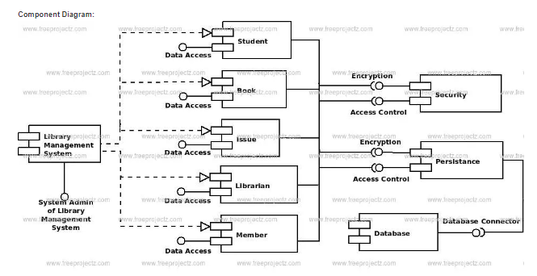
Week13onwards: For each case study:
- Develop sample diagrams for other UML diagrams – state chart diagrams, activity diagrams and deployment diagrams.
STATE CHART DIAGRAM:
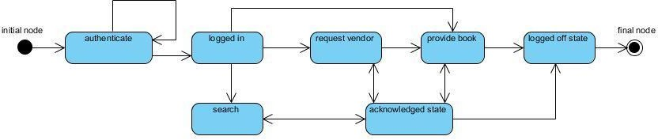

Activity Diagram:
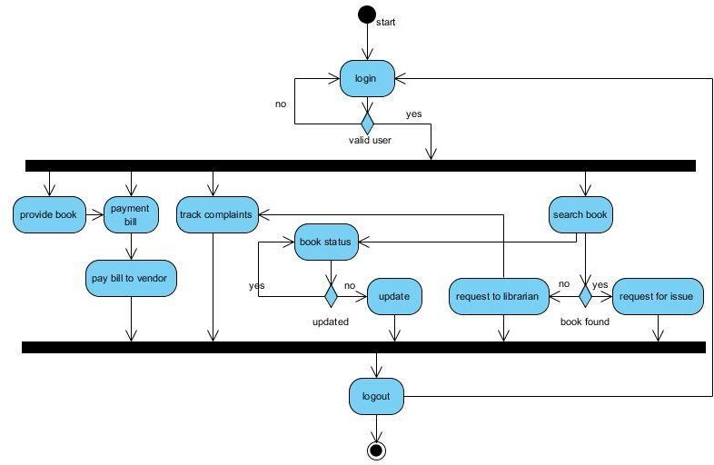

CASE STUDY: E-TICKETING
PROBLEM STATEMENT
Our project is carried out to develop software for online Railway Reservation System. This system has various options like reservation, cancellation and to view details about available seats. Our project mainly simulates the role of a Railway ticket booking officer, in a computerized way. The reservation option enables a person to reserve for a ticket at their home itself. All he/ she has to do is to just login and enter the required details. After this the reservation database is updated with the person details, train name and also the source and destination place. The cancellation option enables the passenger to cancel the tickets that has been already booked by him/her. The availability option prompts the person to enter train number, train name and date of travel. After this the availability database is accessed and available positions are produced.
Week 2, 3&4
Case Study 1: E-TICKETING
- Identify the users and Analyze Events
- Identify Use cases
- Develop event table
- Identify & analyze domain classes
- Represent Use cases & Domain class diagram using Umbrello
- Develop CRUD matrix to represent relationships between use cases and problem domain classes.
a) Identify and Analyze Events
USERS | EVENTS
APPLICANT | The applicant has attribute such as name and password and operations are login, give details and logout. The applicant login and fill the details that are required for applying the passport .After applying the person can view the status of the passport verification process
THE DATABASE | The database has attributed such as name and operation is store. The purpose is to store the data.
REGIONAL ADMINISTRATOR | The regional administrator has attribute such as name and operation are get details, verify details and send. The regional administrator get the details form database and verify with their database
PASSPORT ADMINISTRATOR | The passport administrator has attributed such as name and operation are get details, verify details and issue. The passport administrator get the details form database and verify with their database , update the verification and issue the passport
THE POLICE | The police has attribute such as name and operation are get details, verify details and send. The police get the details form database and verify with their database , update the verification in the database

b) Identify Use cases
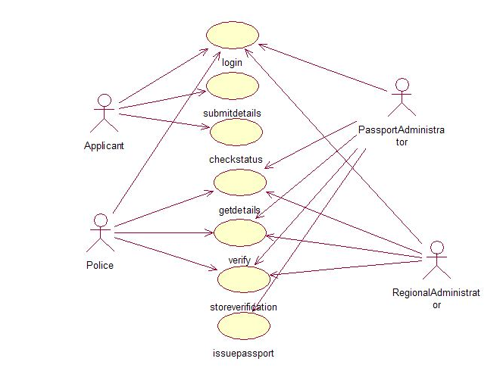
c) Develop event table

 |  | APPLICANT | THE DATABASE | REGIONAL ADMINISTRATOR | PASSPORT ADMINISTRATOR | THE POLICE
The applicant has attribute such as name and password and operations are login, give details and logout. |  | + | * | + | + | +
The database has attributed such as name and operation is store. The purpose is to store the data. |  | + | *
The regional administrator has attribute such as name and operation are get details Verify details | and send. | * | + | + | + | +
The passport administrator has attributed such as name and operation are get details, verify details and issue. |  | * | * | + | + | +
The police has attribute such as name and operation are get details |  | * | * | + | + | +
Verify details and send. The police get the details form database and verify with their database
* Event can occur zero to many times
+ Event can occur zero to one time
d) Identify & analyze domain classes
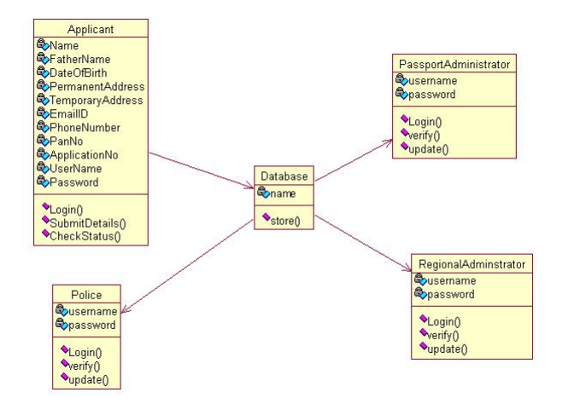

e) Represent Use cases & Domain class diagram using Umbrello
DOCUMENTATION OF USECASE DIAGRAM
a. The actors in use case diagram are Applicant, regional administrator, database, passport Administrator, Police.
b. The use cases are Login, givedetails, logout, collectdetails, verification, issue.
c. The actors use the use case are denoted by the arrow
d. The login use case checks the username and password for applicant, regional administrator, passport administrator and police.
e. The submit details use case is used by the applicant for submitting his details
f. The check status use case is used by the applicant for checking the status of the application process.
g. The get details, verify and store verification use case is used by passport administrator, regional administrator, and police.
h. The details use case is used for getting the details form the database for verification
2. The verify use case is used for verifying the details by comparing the data in the database.
a. The store verification use case is to update the data in the database
b. And finally the issue passport use case is used by the passport administrator for issuing passport who’s application verified successfully by all the actor .
CLASSDIAGRAM
A class is drawn as rectangle box with three compartments or components separated by horizontal lines. The top compartment holds the class name and middle compartment holds the attribute and bottom compartment holds list of operations
DOCUMENTATION OF CLASS DIAGRAM
a. APPLICANT-The applicant has attribute such as name and password and operations are login, give details and logout. The applicant login and fill the details that are required for applying the passport .After applying the person can view the status of the passport verification process
b. THE DATABASE-The database has attributed such as name and operation is store. The purpose is to store the data.
C.REGIONAL ADMINISTRATOR- The regional administrator has attribute such as name and operation are get details, verify details and send. The regional administrator gets the details form database and verify with their database
d. PASSPORT ADMINISTRATOR-The passport administrator has attributed such as name and operation are get details, verify details and issue. The passport administrator gets the details form database and verifies with their database, update the verification and issue the passport
e. THE POLICE-The police has attribute such as name and operation are get details, verify details and send. The police get the details form database and verify with their database, update the verification in the database
f) Develop CRUD matrix to represent relationships between use cases and problem domain classes
CRUD technique – an acronym for Create, Read/Report, Update, and Delete; a technique to
validate or refine use cases
- The CRUD Matrix is an excellent technique to identify the Tables in a Database which are used in any User interaction with a Web Site.
- CRUD means ‘Create, Read, Update or Delete’, and the CRUDD Matrix identifies the Tables involved in any CRUD operation.
- It is very valuable to combine a CRUD Matrix with the analysis of possible User Scenarios for the Web Site
- The analysis helps to identify any Tables which are not used, and any Tables which are used heavily, and may therefore be a performance bottleneck.

 | Passenger | Booking | Reservation | train
Request for seat available | C | R,U | R
Make Reservation | C |  | R,C
Cancellation | D
Check Status | R
Don’t Care | U | C,D | U,D | C,R,U,D

Week-5 & 6
a) Develop Use Case diagrams
b) Develop elaborate Use case descriptions & scenarios
c) Develop Prototypes
d) Develop system sequence diagrams.
a) Use case Diagram
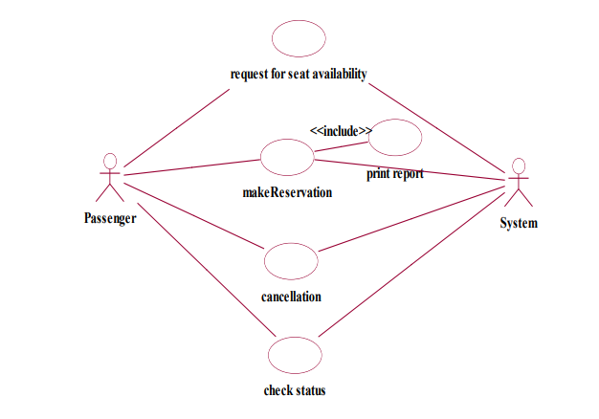
b) Elaborated use-cases descriptions
USE-CASE DIAGRAM
The online ticket reservation system uses the following use cases:
- Request for seat availability
- Make Reservation
- Cancellation
- Check status
- Print ticket

ACTORS INVOLVED:
- System
- Passenger

USE-CASE NAME: REQUEST FOR SEAT AVAILABILITY
The passenger can view the train available in the database for deciding which
train ticket he wishes to reserve. The passenger can search the train information based on journey date, train type and reservation type. The passenger can view the details of flights such as, train number, source station, destination station, arrival time, departure time, fare and number of seats available.

USE-CASE NAME: MAKERESERVATION
The user is allowed to reserve a ticket on train as he/she requires on the particular
date and time. The user has to provide details such as name, train number, date of travel, source station, destination station, proof name and money transaction details.
USE-CASE NAME: PRINT TICKET
The user after booking a ticket can print a copy of the ticket reserved. The user
has to provide the details about ticket number for searching in the database and passenger name for confirming passenger identity.

USE-CASE NAME: CANCEL TICKET
A passenger can decide to cancel a ticket after the ticket is booked. The passenger
has to provide details about ticket for searching and details about him for confirmation of identity.
USE-CASE NAME: CHECK STATUS
The passenger can view the status of the reserved tickets. So the passenger can confirm his/her travel.

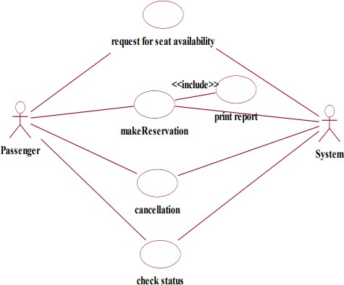
d) Develop system sequence diagrams.
A sequence diagram shows an interaction arranged in time sequence, It shows object participating in interaction by their lifeline by the message they exchange arranged in time sequence. Vertical
dimension represent time and horizontal dimension represent object.
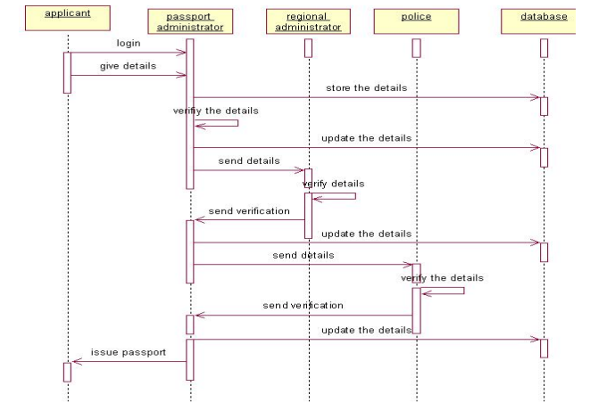
DOCUMENTATION OF SEQUENCE DIAGRAM.
a. The applicant login the database and give his details and database store the details.
b. The passport administrator get the details from the database and do verification and the forward to regional administrator.
c. The regional administrator get details form passport administrator and perform verification and send report to passport administrator.
d. The police get the details form passport administrator and perform verification and send report to passport administrator
Week 7, 8, 9 & 10:
For each case study:
- Develop high-level sequence diagrams for each use case
- Identify MVC classes / objects for each use case
- Develop Detailed Sequence Diagrams / Communication diagrams for each use case showing interactions among all the three-layer objects
- Develop detailed design class model (use GRASP patterns for responsibility assignment)
- Develop three-layer package diagrams for each case study
.
1. high-level sequence diagram for E-Ticketing
Week 11 & 12:
For each case study:
- Develop Use case Packages
- Develop component diagrams
- Identify relationships between use cases and represent them
- Refine domain class model by showing all the associations among classes

COMPONENT DIAGRAM:

Week13onwards: For each case study:
- Develop sample diagrams for other UML diagrams – state chart diagrams, activity diagrams and deployment diagrams.

STATE CHART DIAGRAM
The state chart diagram contains the states in the rectangle boxes and starts in indicated by the dot and finish is indicated by dot encircled. The purpose of state chart diagram is to understand the algorithm in the performing method
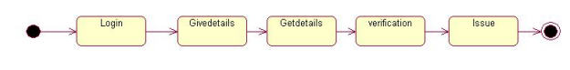
DOCUMENTATION OF STATE CHART DIAGRAM
a. The states of the passport automation system are denoted in the state chart diagram
b. Login state represent authentication for login the passport automation system.
c. In this state, it checks whether the applicant has provided all the details that is required.
d. Police, regional administrator and passport administrator get necessary details and verification of the applicant are denoted from the Get detail state and verification state
ACTIVITY DIAGRAM
An activity diagram is a variation or special case of a state machine in which the states or activity representing the performance of operation and transitions are triggered by the completion of operation. The purpose is to provide view of close and what is going on inside a use case or among several classes. An activity is shown as rounded box containing the name of operation
